- List up to IO different protocols that appear in the Protocol column in the unfiltered packet-listing window.

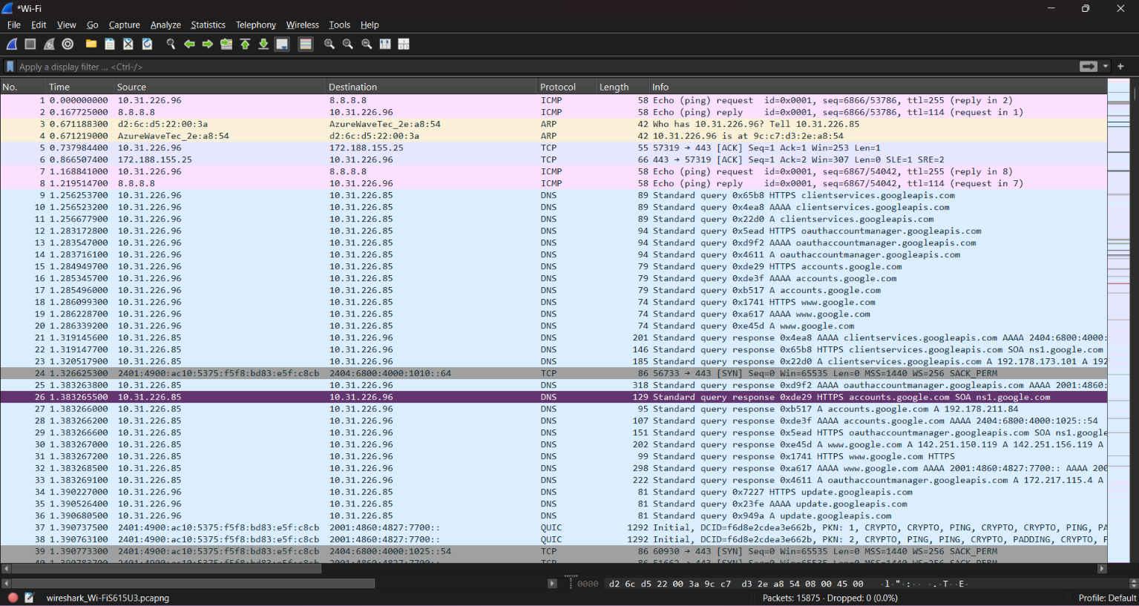

- What is the Internet address of the www.gujaratuniversity.ac.in? What is the Internet address of your computer?
->nslookup www.gujaratuniversity.ac.in
->ipconfig

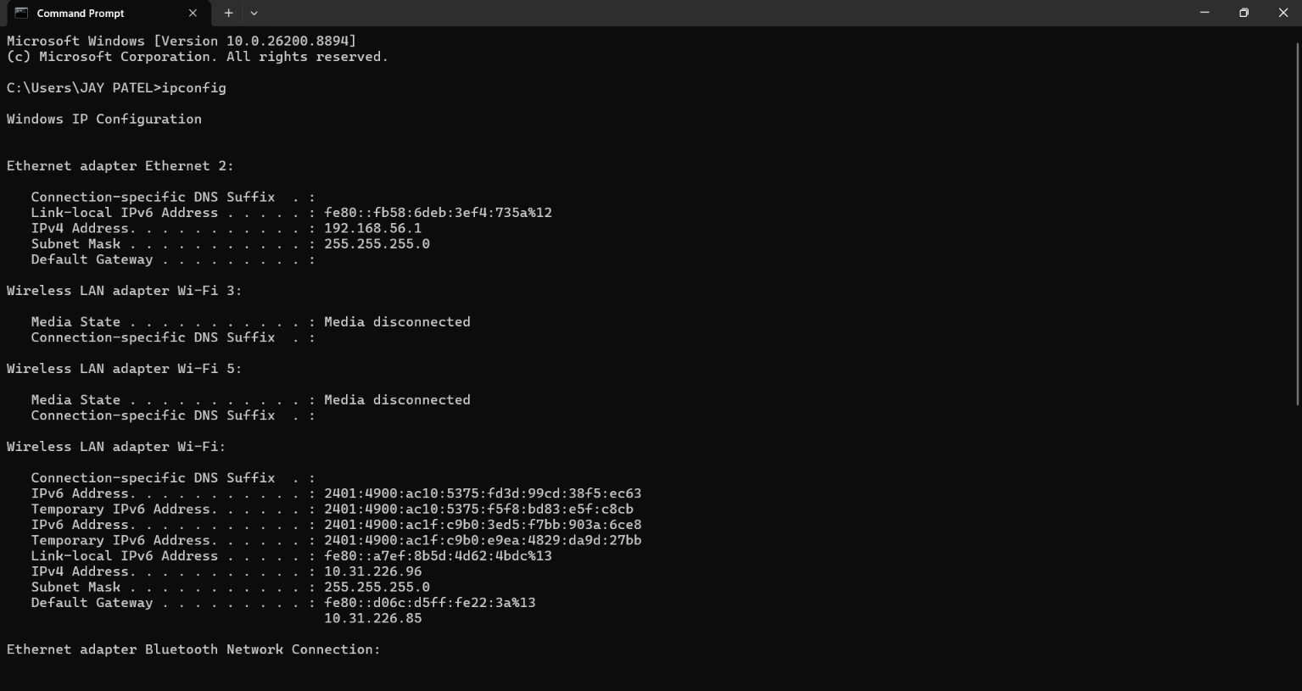
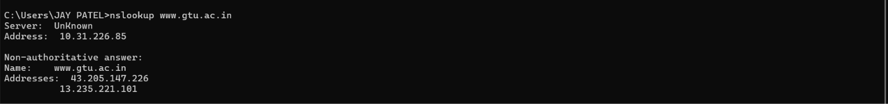

- http protocol only with Wireshark running on your computer.
Total HTTP : 150

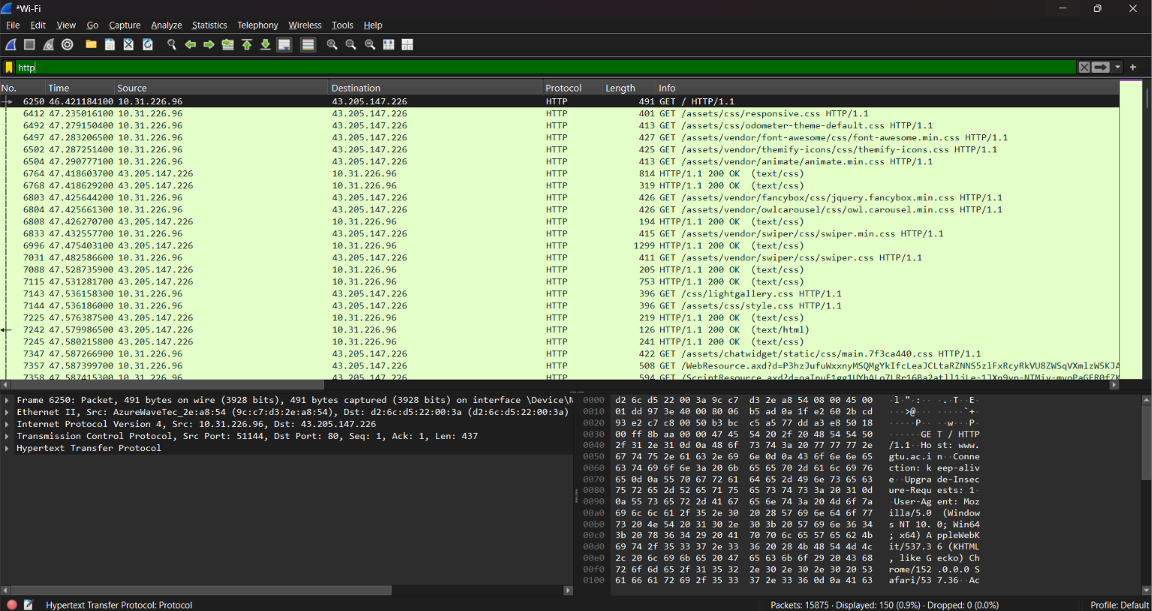

- How many packets did you capture (total of all protocols, not just HTTP)?
Total Pcket : 15875

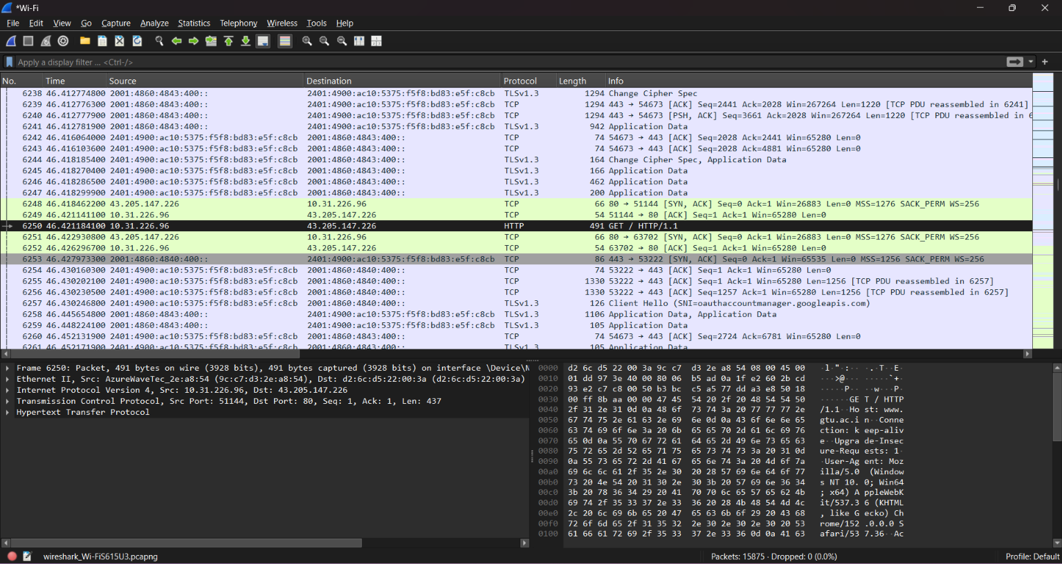

- Now, use display filters to determine how many packets contain your ip address (hint: Use ip.addr instead of the clumsy ip.src or ip.dst format).

ip.addr==10.31.226.85
Ip address = 448 packets

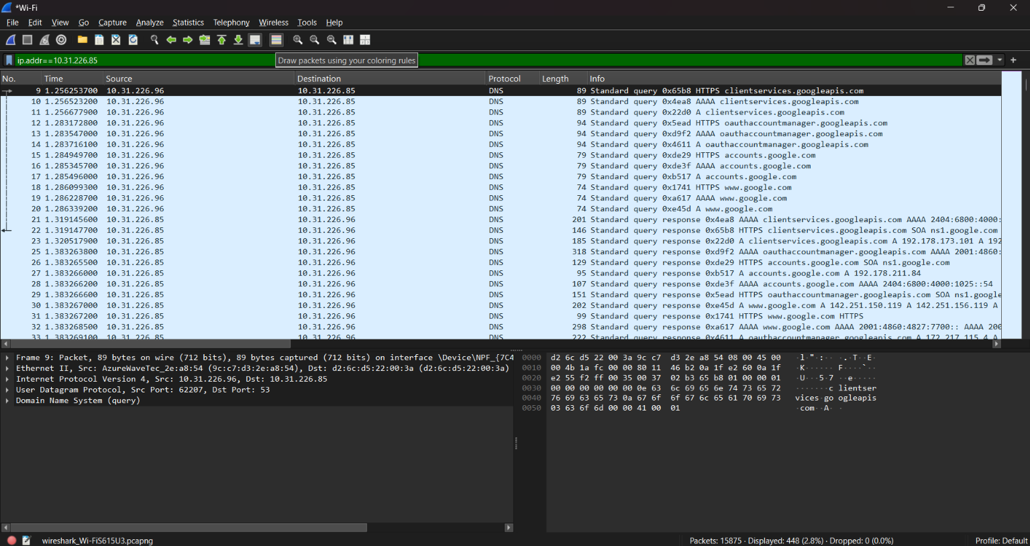

- What is this filter you used? Now, reverse the filter to determine how
many packets don’t contain your ip address.
!ip.addr==10.31.226.85
Ip address: 15427 packets

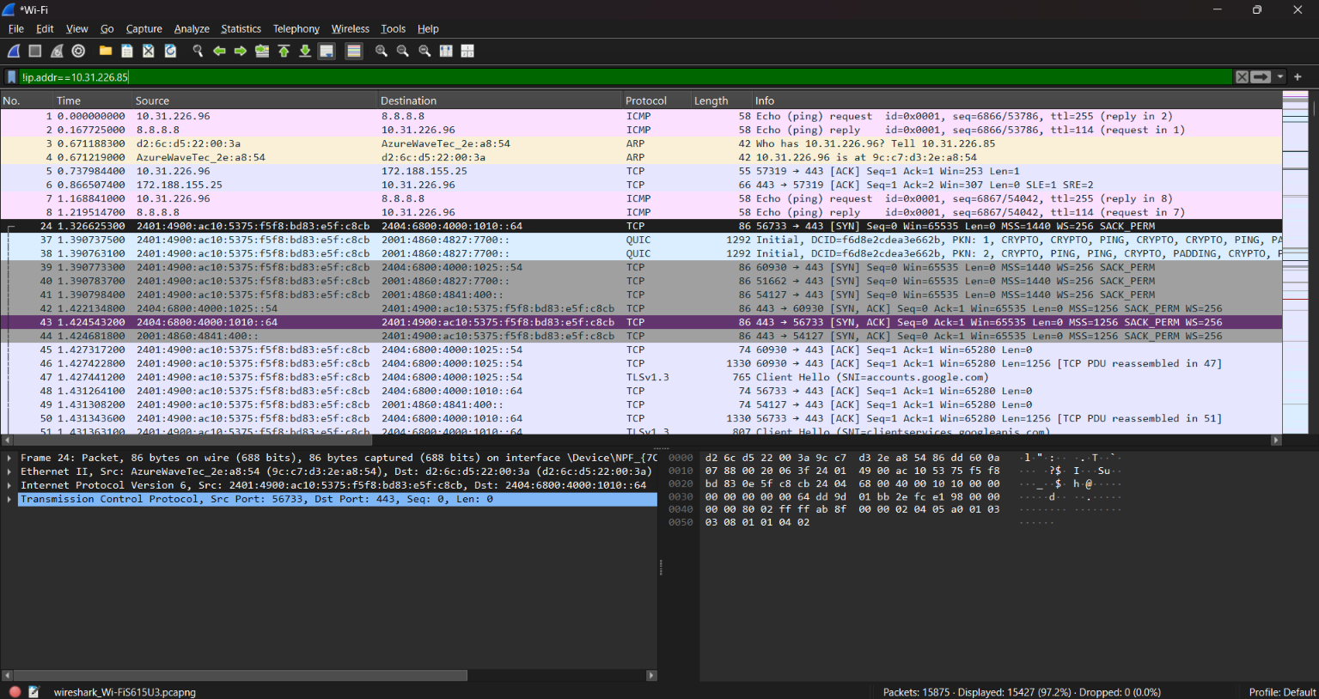

- What is the IP address of your computer? Of the gtu.ac.in server?

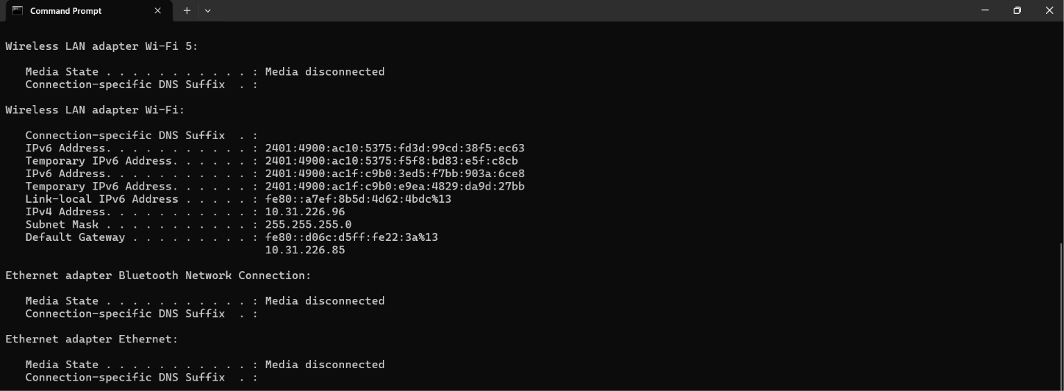
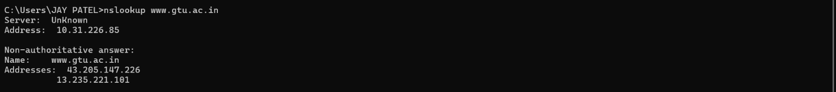

- What HTTP version is your browser running? What version of HTTP is the server running?
Request Version: HTTP/1.1
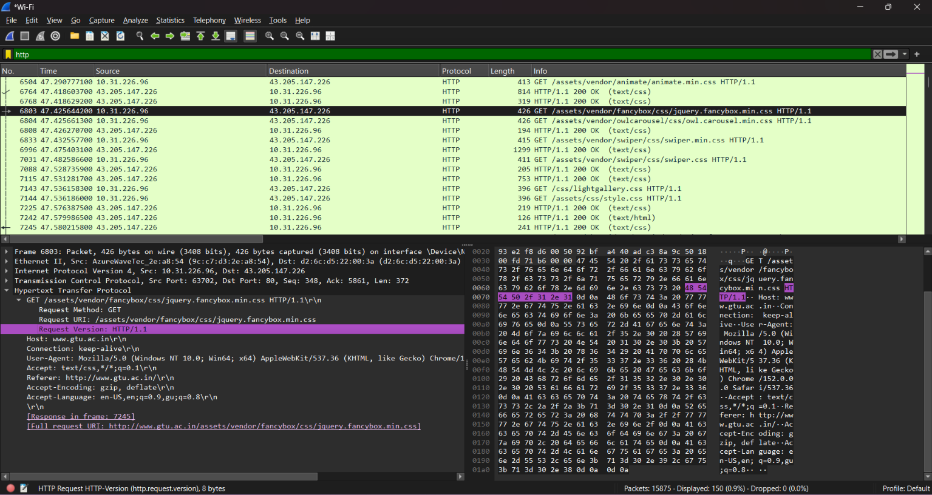

Response Version: HTTP/1.1
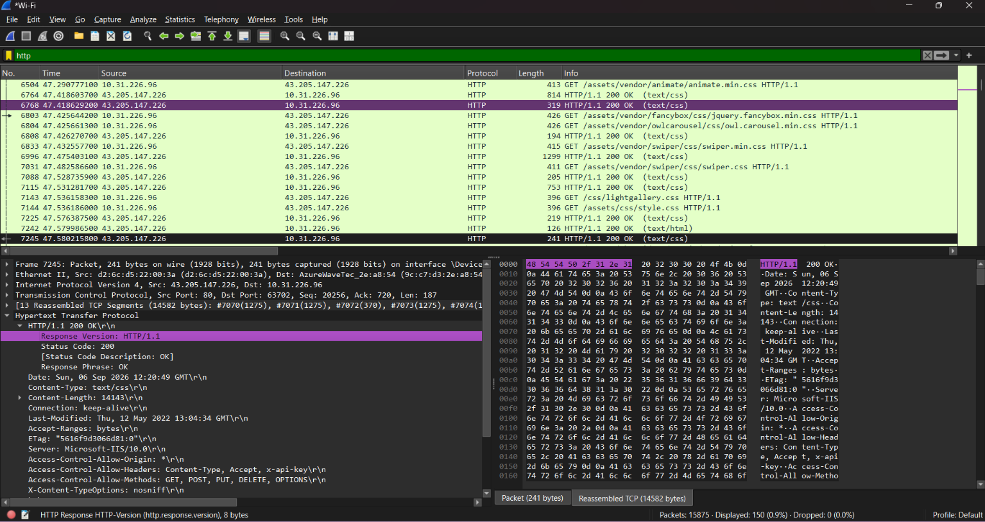

- What is the status code and phrase returned from the server to your browser?
➔ Status code:200
➔ Response phrase:OK

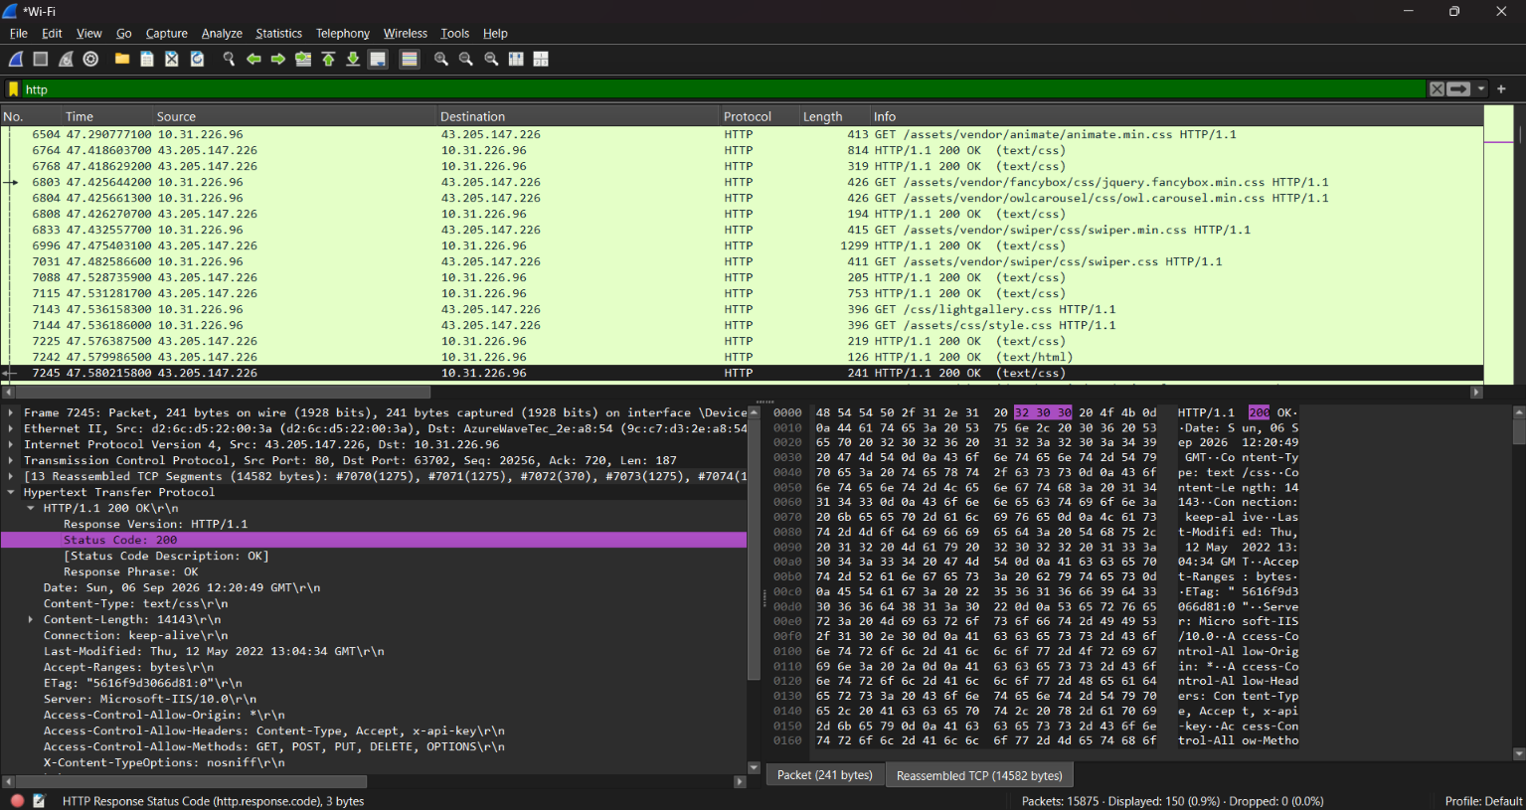

- What languages does your browser indicate to the server that it can
accept? Which header line is used to indicate this information?
Accept-Language: en-US,en;q=0.9,gu;q=0.8\r\n
Accept Language in Header line

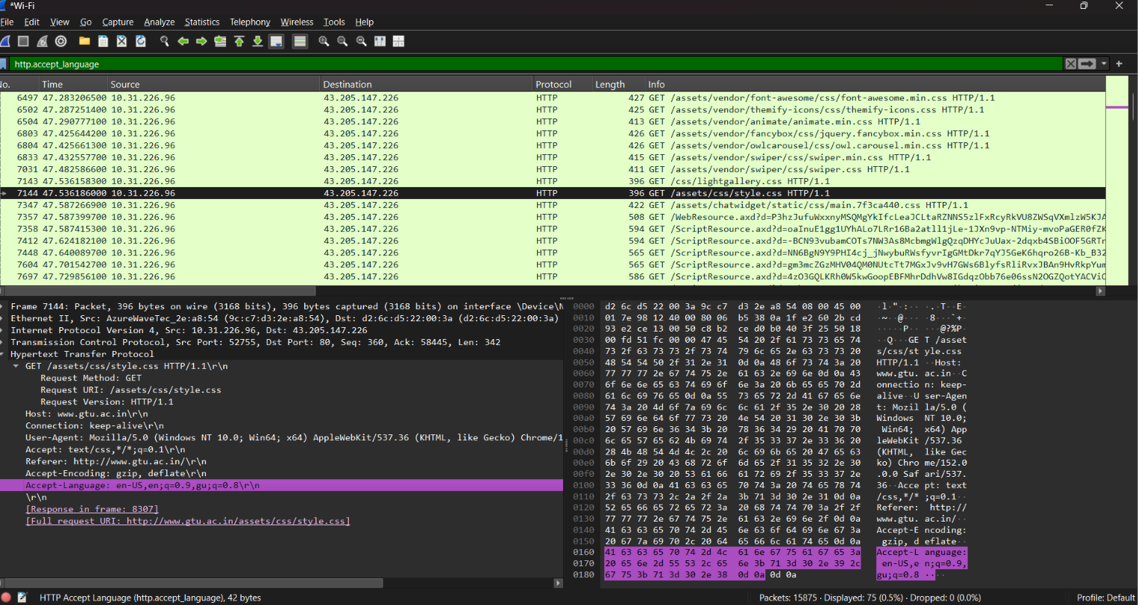

- When was the HTML-file, that you have retrieved, last modified at the server? Which header line is used to indicate this information?
Last-Modified: Thu, 12 May 2022 13:04:34 GMT\r\n

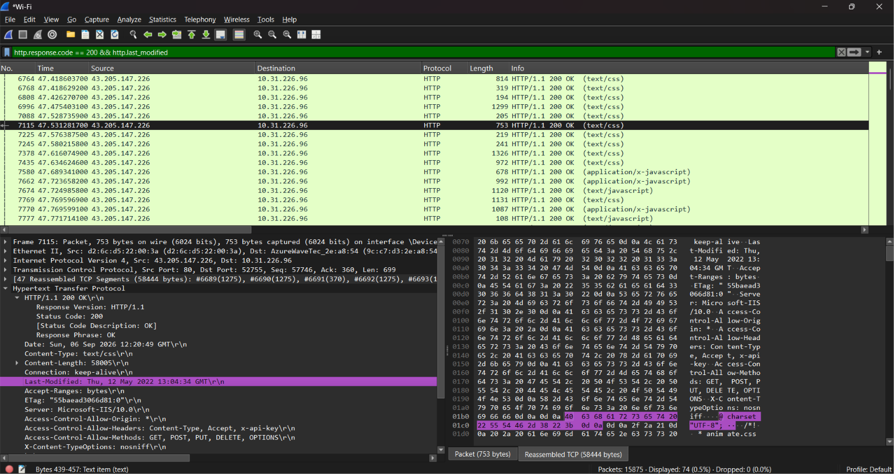

- How many bytes of content (size of file) are returned to your browser? Which header line is used to indicate this information?
(When the server sends the webpage (HTML file) to your browser,
what is the size of that file?)
Content-Length: 18679\r\n

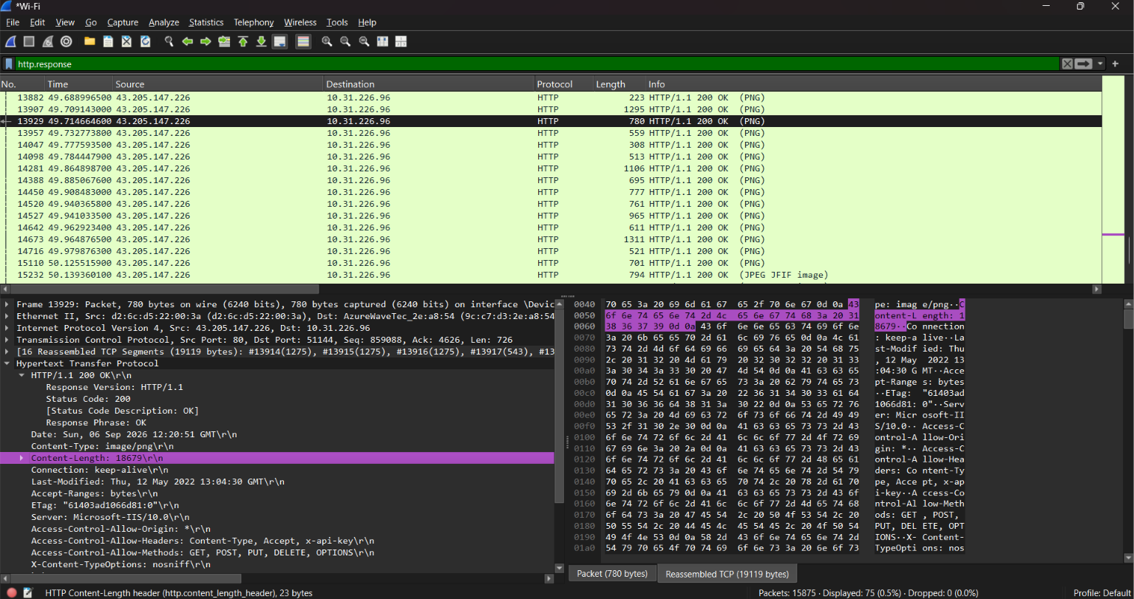

HTTP Conditional GET/Response Interaction
- Start up the Wireshark packet sniffer, and make sure that “http” is in the displayfilter, so that only captured HTTP messages will be displayed in the packet-list pane.
- Enter the following URL into your browser:
http://gaia.cs.umass.edu/wireshark-labs/HTTP-wireshark-file1.html
Your browser should display a very simple HTML file.
15. Quickly enter the same URL into your browser again (or simply select
the refresh button on your browser).
16. Stop Wireshark packet capture.

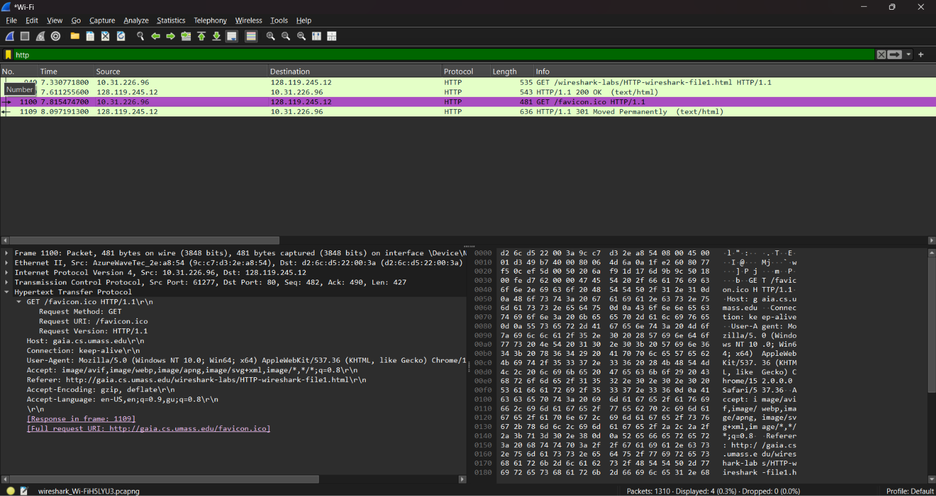

17. Inspect the contents of the first HTTP GET request from your browser to
the server. Is there an “IF-MODIFIED-SINCE” header line in the HTTP
GET message? Why or why not? (1st link - no)
Ans: No. If-Modified-Since is not present because the browser is
requesting the page for the first time. It has no previous copy of the
page, so it simply asks the server to send the page.
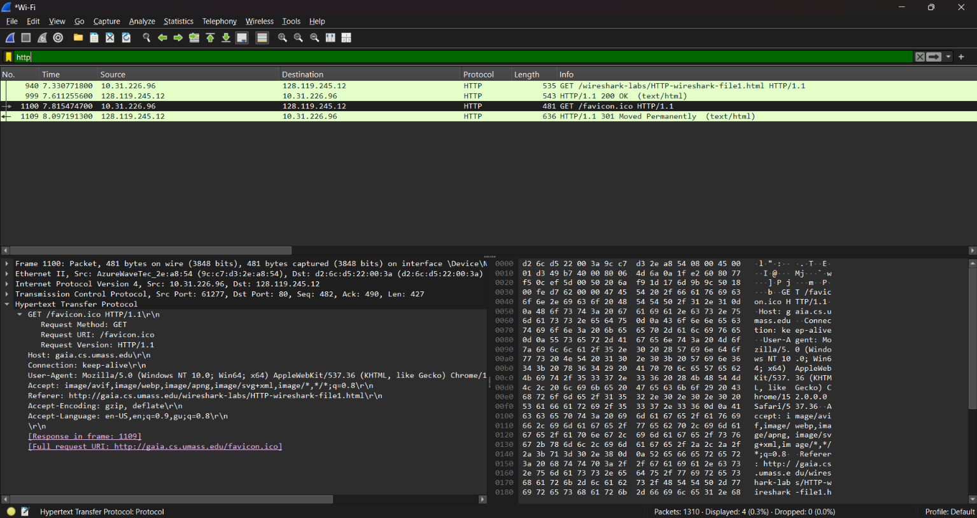

18. Inspect the contents of the server response. Has the server explicitly
returned the contents of the file? How can you tell?
- Yes, the server has returned the contents of the file. Extend line based
text data: Congratulation you‘ve download the file

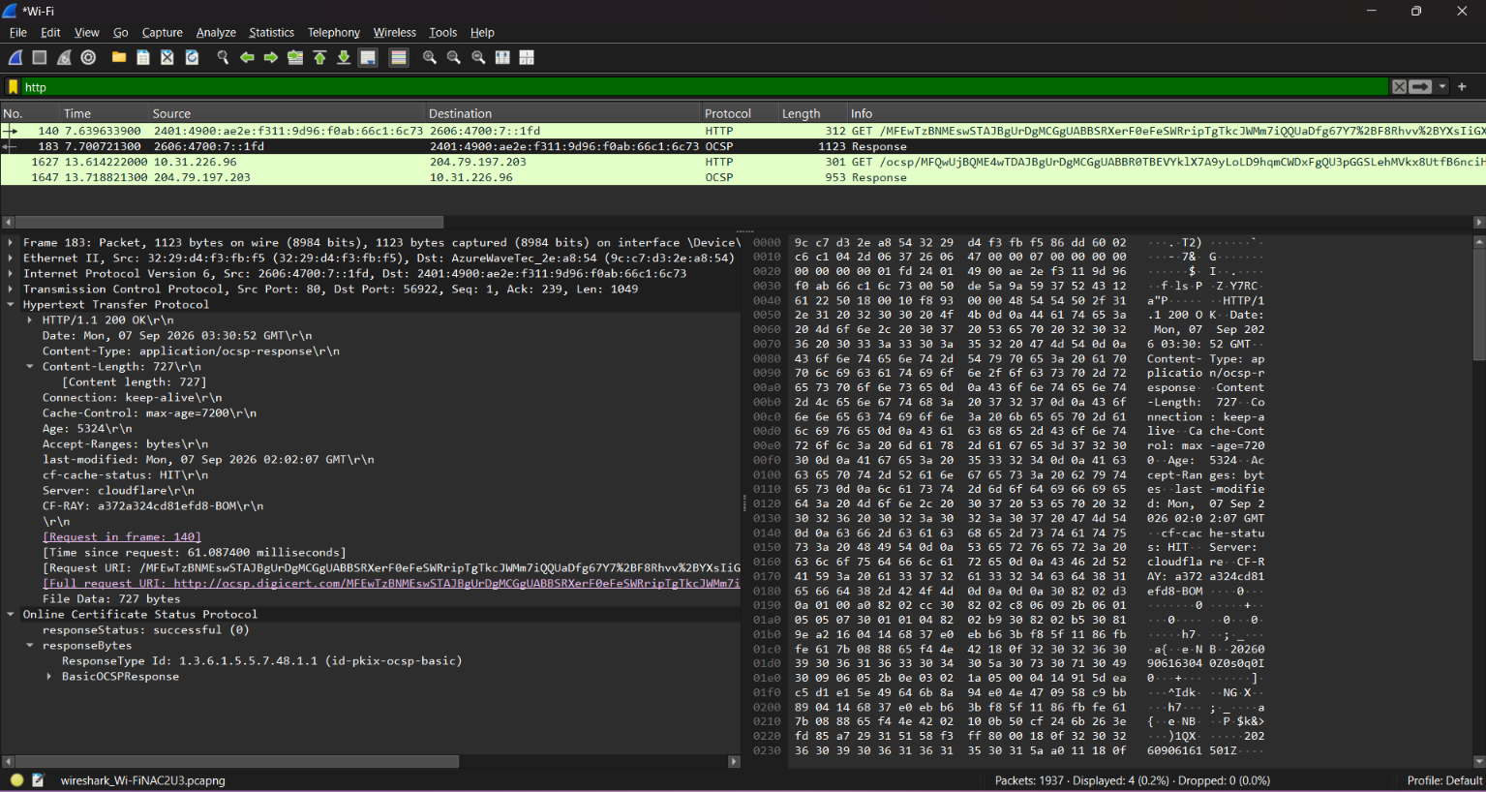

19. Now inspect the contents of the second HTTP GET request from your browser to the server. Is there an “IF-MODIFIED-SINCE:” header line in the HTTP GET message? If so, what information follows the “IF MODIFIED- SINCE:” header line? (second link - yes)
Yes. If-Modified-Since is present because the browser already has a
copy of the page. It asks the server whether the page has changed since
the last time it was downloaded.

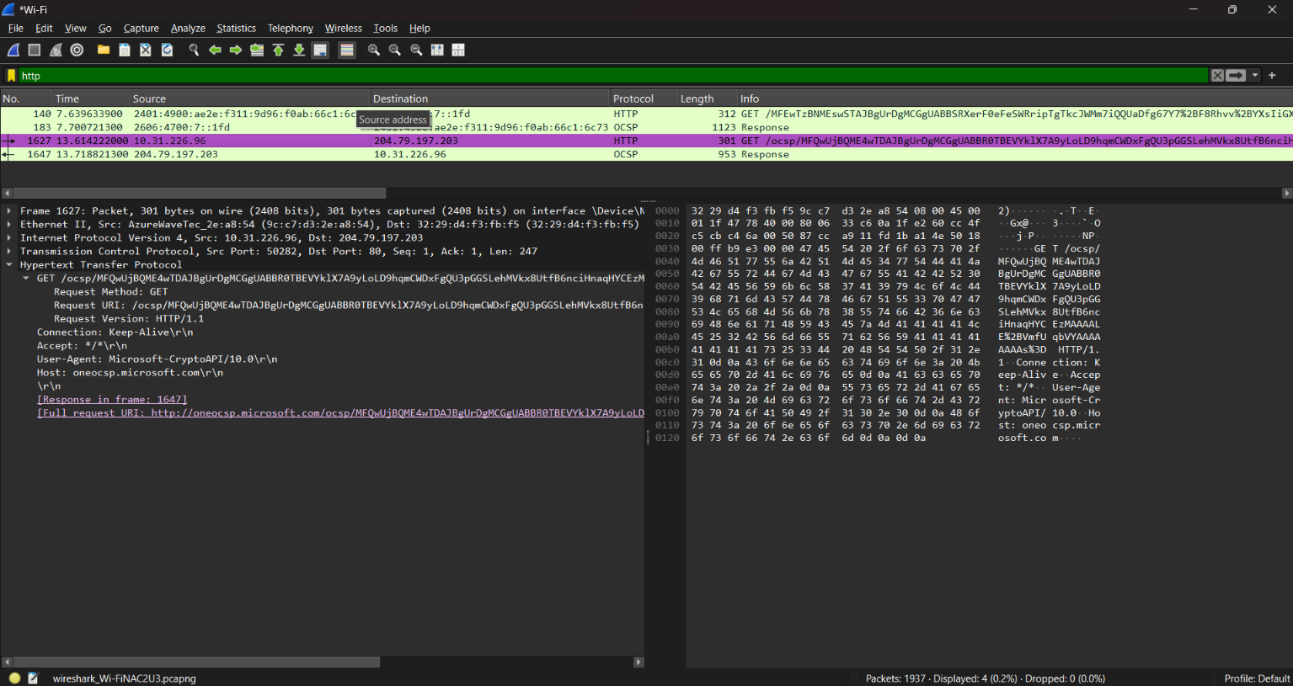

(ans of next que) If it has not changed, the server replies with 304 Not Modified. If yes, the server sends the updated file (200 OK).

20. What is the HTTP status code and phrase returned from the server in response to this second HTTP GET? Has the server explicitly returned the contents of the file? Explain.
➔ Status code:200
➔ Response phrase: Not modified
No, the server has not returned the contents of the file as it is the
response of the second request sent by the browser.

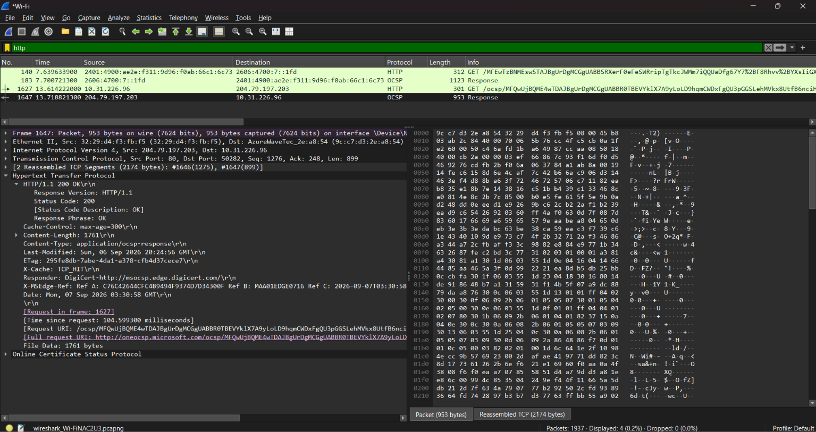

21. How many HTTP GET request messages has your browser sent? Which packet in the trace contains the request for the Bill of Rights? http.request.method=="GET"
(The packet number of that HTTP GET packet is the answer.)
Total HTTP GET request messages :- 2

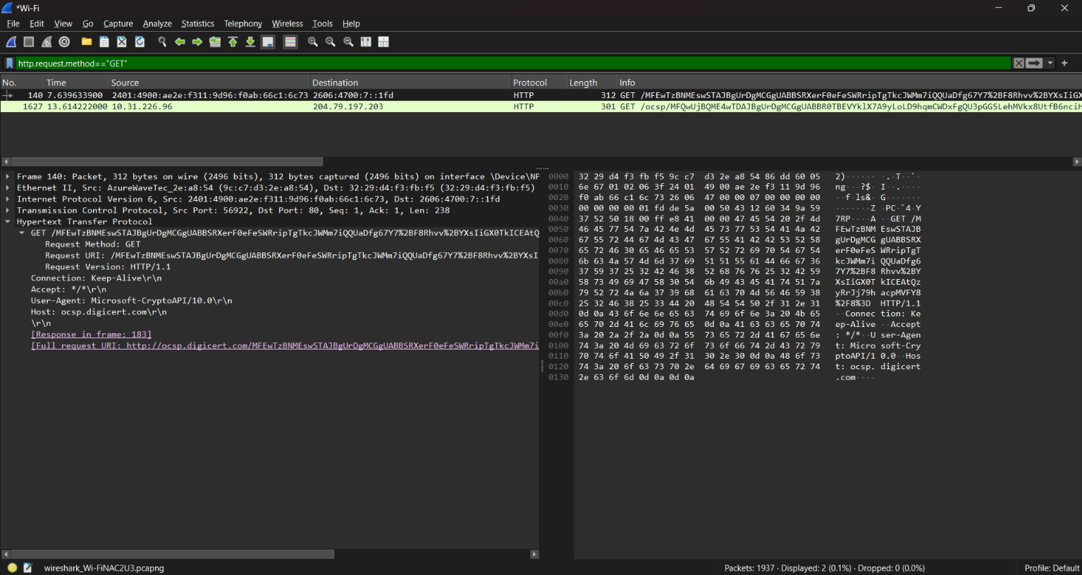

22. Which packet in the trace contains the status code and phrase associated with the response to the HTTP GET request? What is the status code and phrase in the response?
Or
(Which packet contains the server's response to the HTTP GET request? What is the status code and status phrase in that response?)
Status Code :- 200 , Response Phrase :- OK
Packet no of server response is : 1937

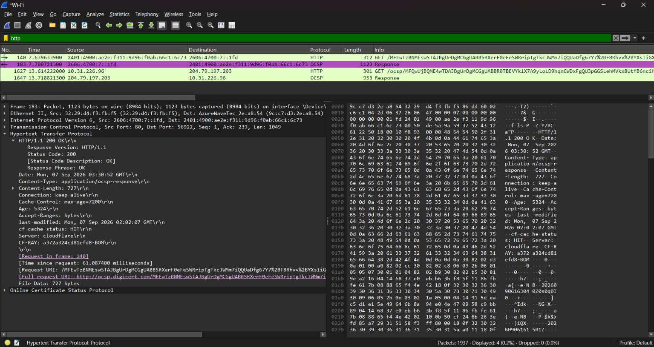

23.Discuss http GET and RESPONSE.

HTTP GET Request:
An HTTP GET request is sent by the browser (client) to the server to request a web page or other resource. It contains information such as the requested URL, HTTP version, and request headers.
HTTP Response:
An HTTP Response is sent by the server back to the browser after receiving the GET request. It contains the status code (such as 200 OK or 304 Not Modified), response headers, and, if required, the requested web page or file.

24.Count the total number of HTTP GET requests.
Enter in filter: http.request.method==GET , then count total ------
marked.
Displayed: 2

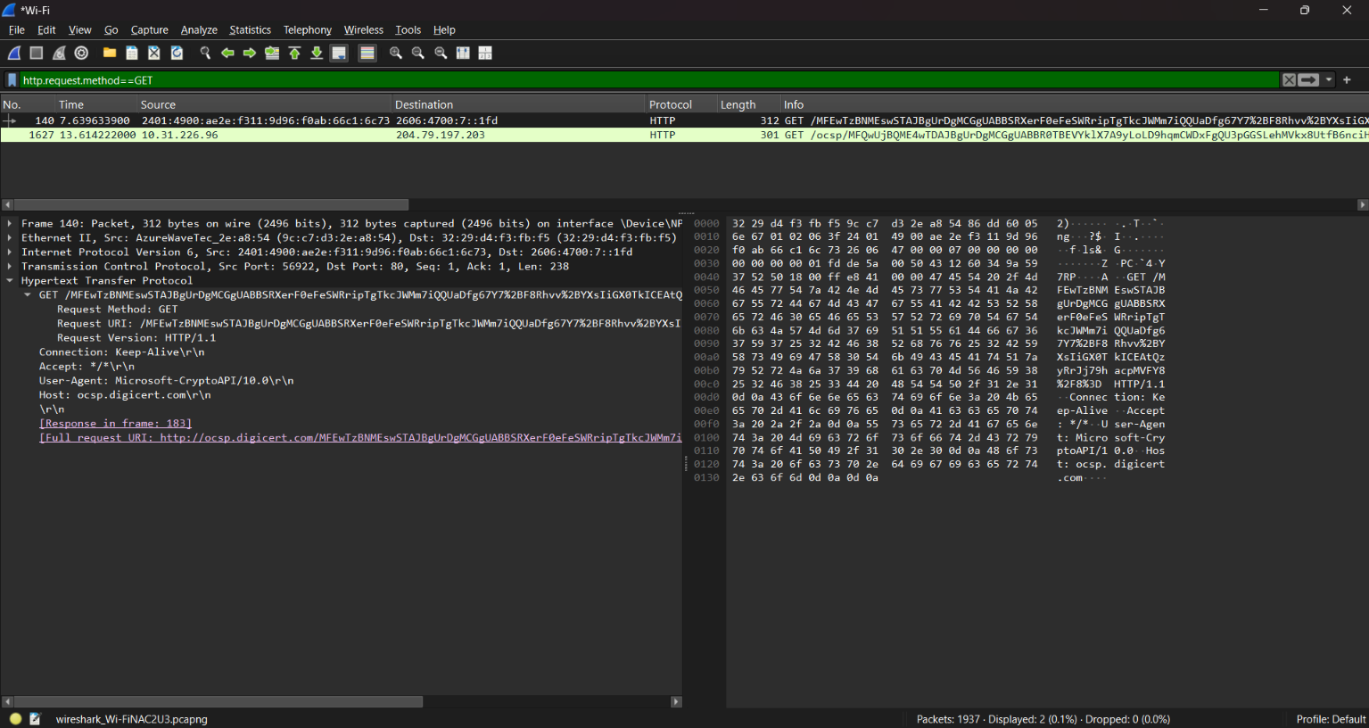

25.How much time elapsed between the first HTTP GET request from client and the HTTP response (OK) from server?
http.request.method==GET || http.response
(Response Time − GET Time = Elapsed Time)
(How much time did the server take to reply after the browser sent the
first HTTP GET request?)

26. Identify the source and destination ports used to transfer the first HTTP GET request
Source Port: 80
Destination Port: 50282

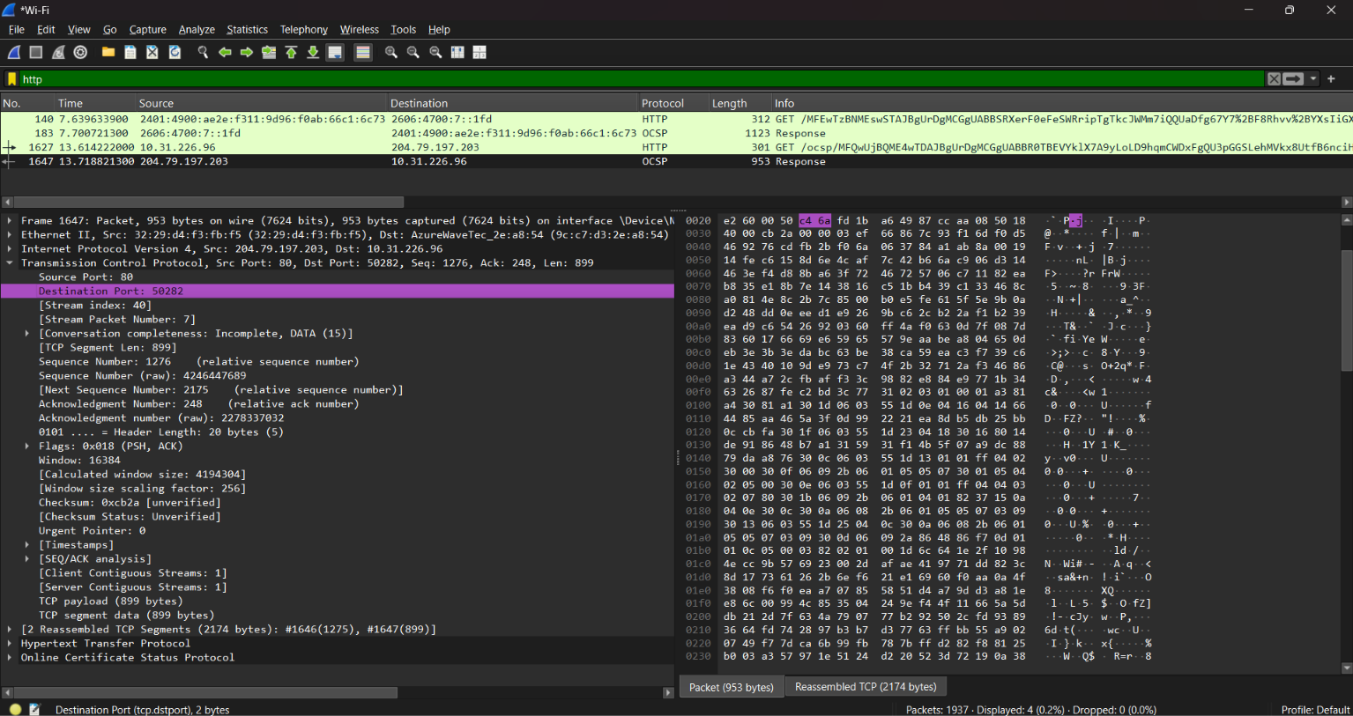

27.Identify the client and server ip address in the first HTTP GET request?
Apply filter http.request.method==GET, see the IP , within this you will
find source ip address and destination ip address.
IP Address: 204.79.197.203
Destination Address: 10.31.226.96

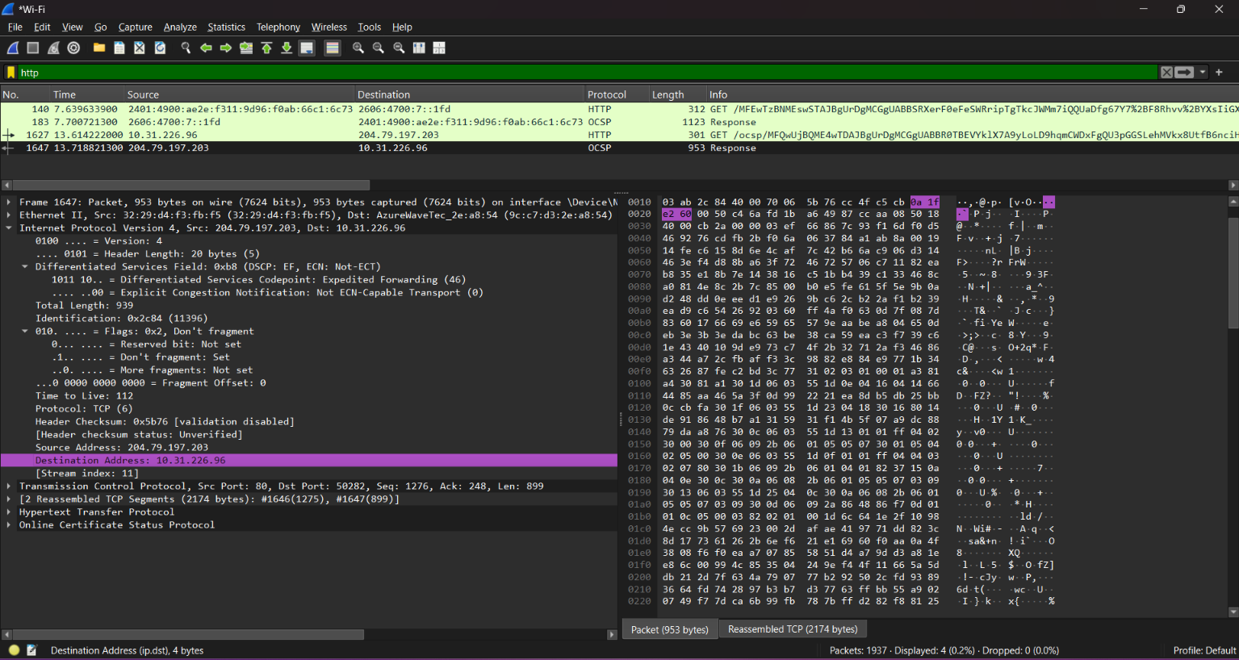

28. Identify the client and server MAC address in the first HTTP GET request?
Apply filter http.request.method==GET, see the Ethernet , within this you
will find source MAC and destination MAC.
Destination: 9c:c7:d3:2e:a8:54
Source: 32:29:d4:f3:fb:f5

